https://themefisher.com/best-free-html5-templates/:
Corlate - Free Responsive Business HTML Template
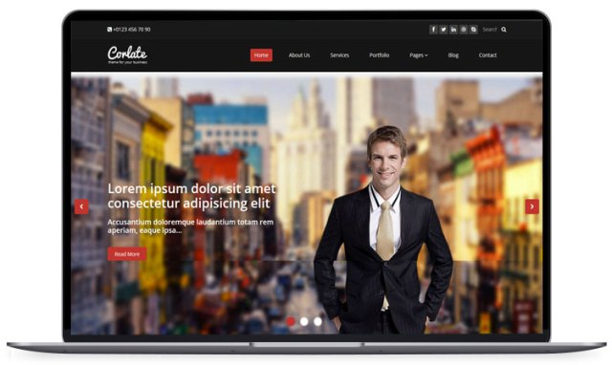
Corlate is another free responsive business HTML CSS template, best suited for those who want to kick-start their company, firm, startup project, even for those professionals want to share their professional work to the world. The lightweight template is powered by bootstrap 3 framework, comes with all modern features of a successful website. The feature includes Font awesome, CSS3 animation, carousel slider, shortcodes.


